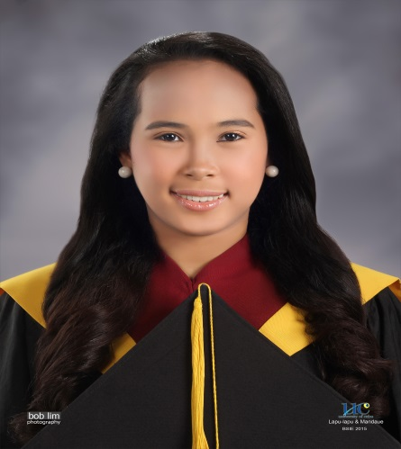

**HOPE, JANET A.**

Applicant

Purok Kawayanan, Gun-ob, Lapu-lapu City

[janet_urhope94@yahoo.com](mailto:janet_urhope94@yahoo.com)

09336165300

Carrier Objective

To join a team that offers opportunities for growth to further develop my skills and contribute to the development of the company's progress and success.

|  |
| --- |
| PERSONAL |

Date of birth : May 11, 1994

Place of birth : Biliran, Leyte

Age : 20

Height : 5'2”

Status : Single

Language Spoken : English, Filipino, Cebuano and Waray

Religion : Roman Catholic

Citizenship : Filipino - American

Skills : morally esteemed, proficient in interpersonal skills, can adopt easily to working environment.

|  |
| --- |
| EDUACTIONAL ATTAINMENT |

ELEMENTARY

Cabucagayan Central School

Caabucgayan, Biliran, Leyte

March, 2006

SECONDARY

Cathedral School of La Naval

Naval, Biliran, Leyte

March, 2010

COLLEGE

University of Cebu Lapu-lapu and Mandaue

A. C. Cortes Ave., Looc, Mandaue City

Bachelor of Science in Industrial Engineering

March, 2015

|  |
| --- |
| SEMINARS ATTENDED |

Leadership Training Seminar

Philippine Institute of Industrial Engineers Visayas Chapter

September 2012

Customer Relationship Management

January 2013

Office Management Seminar

March 2014

Line Balancing & Problem Solving Tools

Philippine Institute of Industrial Engineers (PIIE-UCLM)

March 2014

|  |
| --- |
| WORKING EXPERIENCE |

**PROCEESS ENGINER – Feeder Apparel Corporation 2**

Sports City International

Mez 1, Lapu-lapu City

April – June 2014

|  |
| --- |
| AFFILIATIONS |

**Philippine Institute of Industrial Engineers – UCLM Chapter**

University of Cebu Lapu-lapu and Mandaue

Auditor, June 2014

**Allied Engineering Council – UCLM Chapter**

University of Cebu Lapu-lapu and Mandaue

Board of Director, June 2013

|  |
| --- |
| CHARACTER REFERENCES |

**Engr. Roland Fernandez**

Chairperson, College of Allied Engineering

University of Cebu Lapu-lapu and Mandaue

345-666 Loc. No.229

**Engr. Teodorico Mejaran Jr.**

College Instructor

University of Cebu Lapu-lapu and Mandaue

345-666 Loc. No.229

**Engr. Leo Arrabis Jr.**

College Instructor

University of Cebu Lapu-lapu and Mandaue

09328713580